Rowantree Primary School

Newsletter August 2026

It is so lovely to welcome everyone back for a new school year and to have us all together again as part of the Rowantree Family. A particularly warm welcome goes to our new P1 children, who have settled into school so well and have already made such a positive start to their learning journey.

I would also like to thank all families for the effort you have made with school uniform—it is wonderful to see our children looking so smart and ready for learning each day. If you require any support with school uniform, please speak to Doug Millar, our School and Family Development Worker, who will be very happy to help.

You should now also have received a Seesaw QR code, which will give you access to Seesaw and allow you to keep up to date with your child’s learning and school updates. Please contact the school should you need any assistance with this.

Car Park
May I kindly remind parents and carers that the school car park is designated for staff use only. We appreciate that some families have Blue Badge holders who may need to use the accessible parking spaces, and we ask that these spaces are used appropriately and considerately. Please also be mindful that school transport requires access to these spaces to safely collect and drop off children with additional support needs. We therefore ask all parents and carers to help us keep these areas clear and accessible, ensuring that children and families who rely on them can access the school safely. Thank you for your understanding and cooperation.

Below are important dates for your diary:

Open Doors | 2nd October 2026
School closes for Oct break | 9th October 2026
School reopens | Monday 26th October
Halloween Dress Up | Friday 30th October
Parent Contact nights | Monday 9th & Wednesday 11th Nov

Staff Updates
Doug Millar, our School and Family Development Worker, will now be with us four days a week, with Wednesday as his day off. Mrs McInally will work in the office Tuesday–Thursday, with Mrs Gibb covering Monday and Friday.
We warmly welcome Mrs Jan, Miss Donnelly and Miss De-Lloyd to our teaching team this session, and welcome back Miss Doig and Mrs McGheoghie.

Before the holidays, we said goodbye to Mrs Harper, who is moving on to pastures new and will have more time to spend with her family. We wish her all the best!

Attendance
We will continue to focus on attendance this session. If your child is absent due to illness, please contact the school office on 01382 307870. If your child is well enough to attend but requires medication, we can arrange to administer it. If we do not hear from you regarding an absence, we will contact you by text or phone.
Mobile phones
Children are not permitted to use mobile phones during the school day. We understand that some children may need to bring a phone to school, but these should be handed to their class teacher on arrival and will be kept safely until the end of the school day. If a child needs to contact a parent or carer during the school day, this can be arranged through our office staff. We appreciate your support in reinforcing these expectations with your child. Where children do not follow the school’s expectations regarding mobile phones, their parents or carers will be contacted.
Parent Portal
Please also remember to sign up to Parent Portal using the QR codes provided below, as this is now the way in which progress reports will come out to you. You can also use the Parent Portal to check on your child’s attendance and book their lunch choices in advance should you wish to.

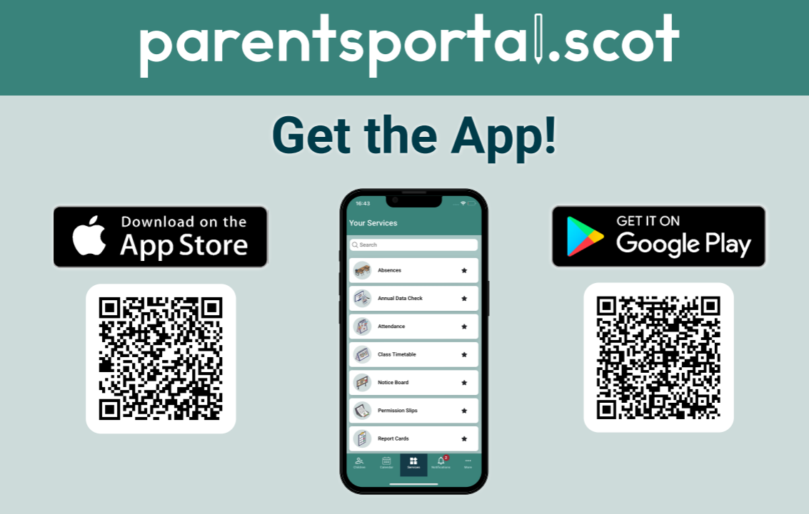

Thank you for your continued support, we are all looking forward to an exciting and busy new session!
Yours sincerely,

T Ross
Headteacher

